Table of Contents
SMARTLIBRARY APPLICATION FULL PROJECT DOCUMENTATION REPORT 2
Introduction 2
Requirements Specification (Week 5 Deliverable) 3
Actors 3
Use Cases 3
Login 3
Manage Books (CRUD) 3
Manage Authors (CRUD) 3
. Manage Members (CRUD) 3
Borrow Book 4
Return Book 4
Manage Book Clubs (CRUD) 4
Dashboard 4
Functional Requirements 4
Authentication 4
Book Management 4
Member Management 5
Loan Workflow 5
Book Club Management 5
Dashboard 5
Non-Functional Requirements 5
Performance 5
Security 5
Usability 6
Reliability 6
Wireframes / Screens 6
Database Design 7
ER Diagram 7
Table Structures 8
users 8
books 8
loans 8
Normalization 8
Indexing 8
Class Design 9
9
Base Classes 9
Entities 9
Inheritance 10
Encapsulation 10
Data Access Layer (psycopg2) 10
Business Rules Enforcement 10
Rule 1: Max 3 active loans 10
Rule 2: Loan due date = 7 days 10
Rule 3: Role-based access 10
GUI Development 11
Screens Implemented 11
GUI Database Connection 11
Event Handlers 11
Integration & Business Rules 11
Loan Workflow 11
Return Workflow 12
Dashboard Integration 12
Git Workflow 12
Pull Requests 12
CI/CD (GitHub Actions) 12
Commit Message Standard 13
Conclusion 14

SMARTLIBRARY APPLICATION FULL PROJECT DOCUMENTATION REPORT

Introduction

The SmartLibrary System is a desktop-based application designed for Limkokwing University’s central library. It provides an integrated platform that manages books, authors, members, book clubs, loans, and authentication using a Python (OOP) backend, PostgreSQL database, and PyQt5 GUI.
This report documents the requirements, database design, backend OOP structure, GUI implementation, integration logic, and development workflow for the completed system.

Requirements Specification (Week 5 Deliverable)

Actors
Actor | Description
Librarian | Manages books, authors, members, book clubs, and loan approvals. Has highest privileges.
Member (Student) | Searches catalog, views clubs, borrows and returns books (max 3).
System | Validates credentials, enforces rules, logs transactions.

Use Cases

Login
- Actors: Librarian, Member
- Description: User enters username & password. System validates and loads role-based dashboard.

Manage Books (CRUD)
- Add, edit, delete, search, and filter books.
- Librarian only.

Manage Authors (CRUD)
- Librarian only.

. Manage Members (CRUD)
- Librarian only.

Borrow Book
- Member selects book → system checks availability → enforces max 3 loans → sets due date = 7 days.

Return Book
- Member returns → system updates loan record → calculates overdue days.

Manage Book Clubs (CRUD)
- Librarian creates clubs.
- Members can view and join.

Dashboard
- View statistics: most borrowed books, active clubs, active loans count.

Functional Requirements

Authentication
- R1: System must authenticate users with username/password.
- R2: Different dashboards for librarian and member.

Book Management
- CRUD operations.
- Search, filter, and sort by title, author, category, availability.

Member Management
- CRUD operations.
- View loan history.

Loan Workflow
- Maximum 3 active loans per member.
- Loan duration = 7 days.
- Automatically set due date.
- Prevent borrowing if book unavailable.

Book Club Management
- Create/edit/delete clubs.
- Assign members to clubs.

Dashboard
- Show statistics and summaries.

Non-Functional Requirements

Performance
- Queries should respond < 2 seconds.
- UI should load < 3 seconds.

Security
- Hashed passwords.
- Role-based access control (RBAC).
- Restricted database permissions.

Usability
- Clean navigation.
- Error messages and input validation.

Reliability
- System should recover from failed DB connection.
- Proper exception handling.

Wireframes / Screens
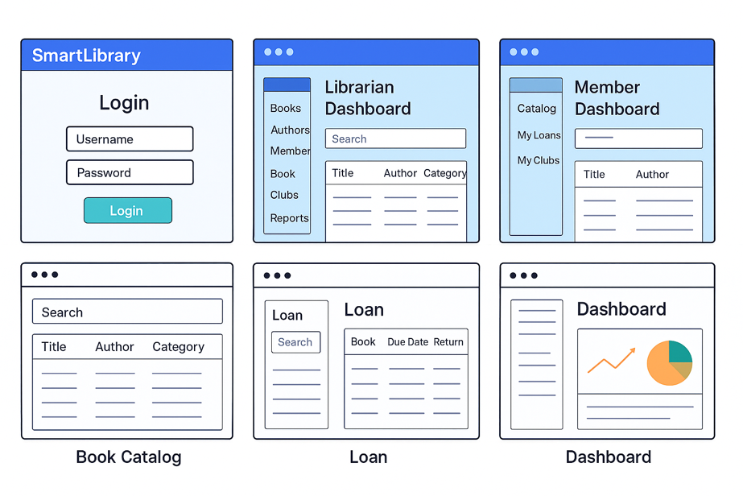

Suggested Screens:
- Login Page
- Member Dashboard
- Librarian Dashboard
- Book Catalog
- Loan Window
- Club Management Window
- Statistics Dashboard

Database Design

ER Diagram
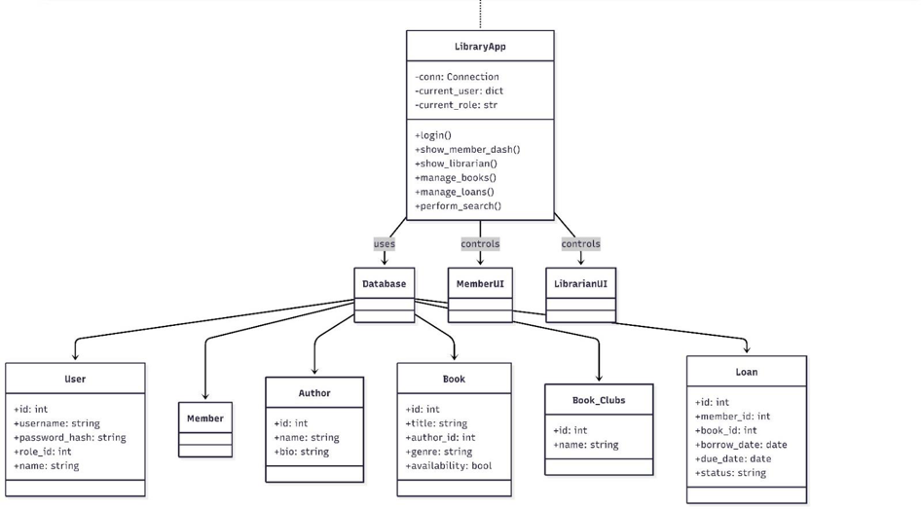

Tables include:
- users
- roles
- books
- authors
- members
- book_clubs
- loans
- club_members

Table Structures

users
Column | Type | Description
user_id | SERIAL PK | Unique ID
username | VARCHAR(50) | Login name
password_hash | TEXT | Encrypted password
role_id | INT FK | Librarian/Member

books
Column | Type
book_id | SERIAL
title | VARCHAR
author_id | INT
category | VARCHAR
copies_available | INT

loans
Column | Type
loan_id | SERIAL
member_id | INT
book_id | INT
loan_date | DATE
due_date | DATE
returned_date | DATE

Normalization
- All tables normalized to 3NF:
  - No repeating fields.
  - Every non-key attribute depends on the key.
  - Junction tables used for M:N relationships (book_clubs).

Indexing
- Index on username for faster login.
- Index on book.title for faster search.
- Index on foreign keys (book_id, member_id).
Backend Logic

Class Design
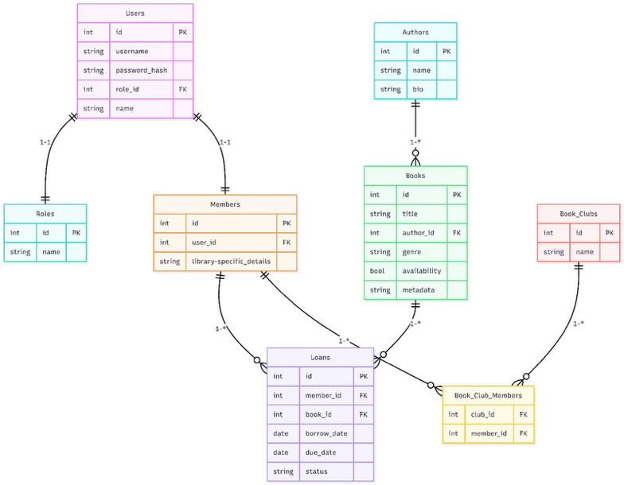

Base Classes
- User
- Role

Entities
- Book
- Author
- Member
- BookClub
- Loan

Inheritance
- Librarian(User)
- Member(User)

Encapsulation
- Private attributes using __attribute
- Getter/setter using @property

Data Access Layer (psycopg2)
- BookRepository
- AuthorRepository
- LoanRepository

Each handles:
- Insert
- Update
- Delete
- Fetch

Business Rules Enforcement

Rule 1: Max 3 active loans
if active_loans >= 3:
raise Exception("Maximum loan limit reached.")

Rule 2: Loan due date = 7 days
due_date = loan_date + timedelta(days=7)

Rule 3: Role-based access
if user.role == "Librarian":
unlock_admin_pages()

GUI Development

Screens Implemented
- Login Screen
- Librarian Dashboard
- Member Dashboard
- Book Catalog
- Loan/Return Window
- Book Club Management
- Dashboard (Charts + Summary)

GUI Database Connection
Using psycopg2:
conn = psycopg2.connect(
database="smartlibrary",
user="postgres",
password="*****",
host="localhost",
port="5432"
)

Event Handlers
Examples:
- Login button → authenticate
- Borrow button → execute loan workflow
- Add Book button → open form and save to DB

Integration & Business Rules

Loan Workflow
- User selects a book
- System checks available copies
- System checks loan limit
- Inserts loan record
- Decreases available copies

Return Workflow
- User selects active loan
- System sets returned_date
- Increases copy count

Dashboard Integration
- Query DB for statistics
- Update charts in PyQt5
Collaboration & DevOps Workflow

Git Workflow
- Branches:
  - feature/login
  - feature/books
  - feature/loans
  - feature/clubs
  - bugfix/ui-issues

Pull Requests
- Every merge required code review.

CI/CD (GitHub Actions)
Jobs included:
- Run SQL migrations
- Linting via flake8
- Unit tests execution

Commit Message Standard
Format:
feat: added loan workflow
fix: corrected book filter bug
doc: updated README

Conclusion

The SmartLibrary system successfully integrates Python OOP, PostgreSQL, psycopg2, and PyQt5 to deliver a complete library management solution for Limkokwing University. The system meets all academic requirements CRUD operations, database normalization, UI design, business rule enforcement, and DevOps workflow.

